Name: Rithik Sarvesh Bharathiraja

UID: 120395246 (gbr2001)

Course: ENPM696

Task: In-class exercise 3

1. Remnux VM

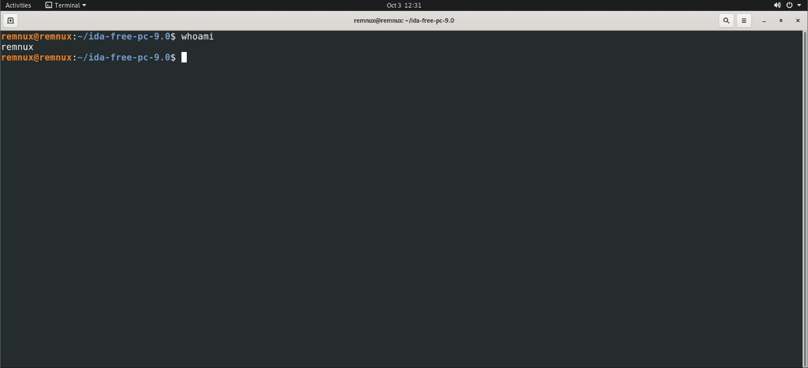

IDA free

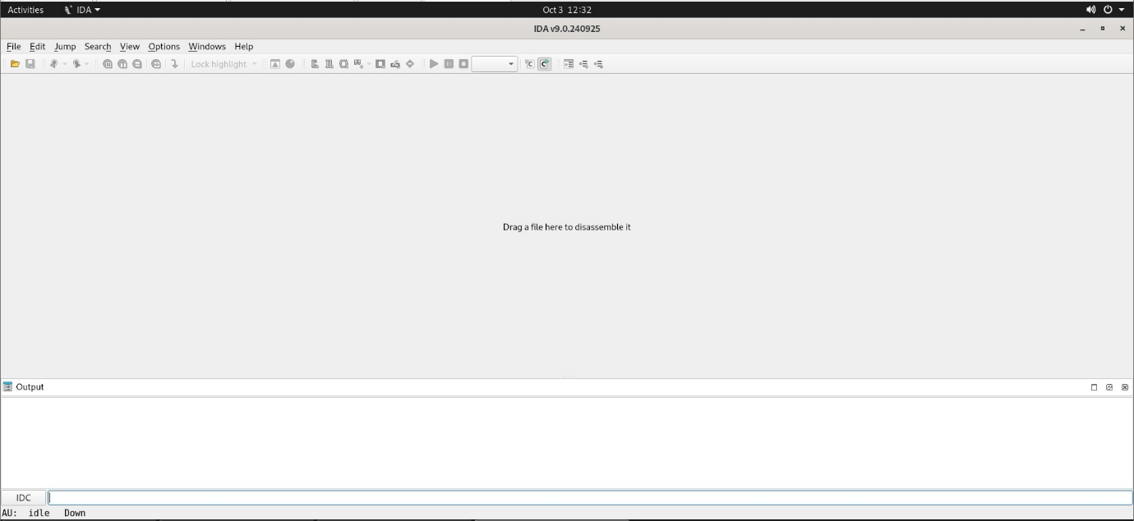

C/C++ tools

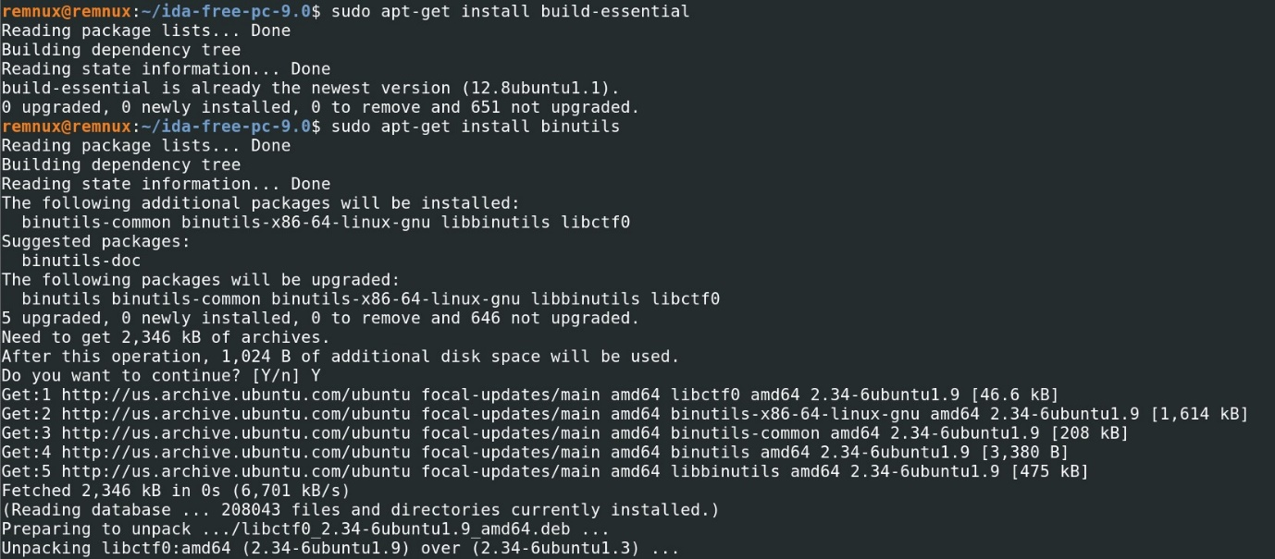

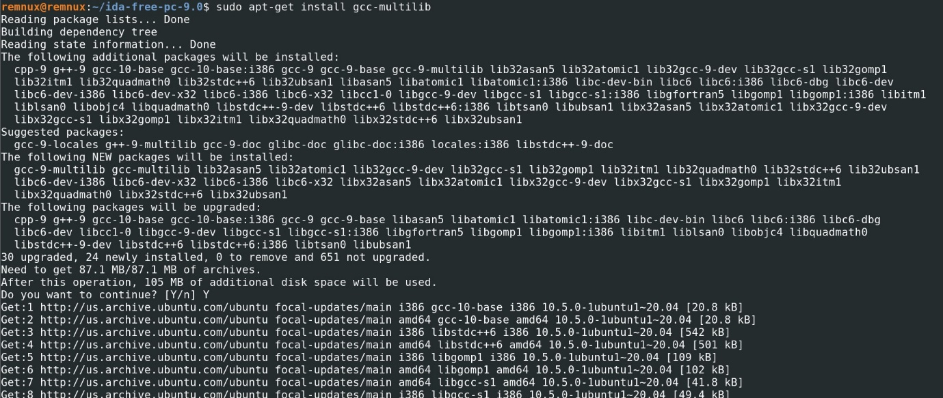

Windows reversing environment

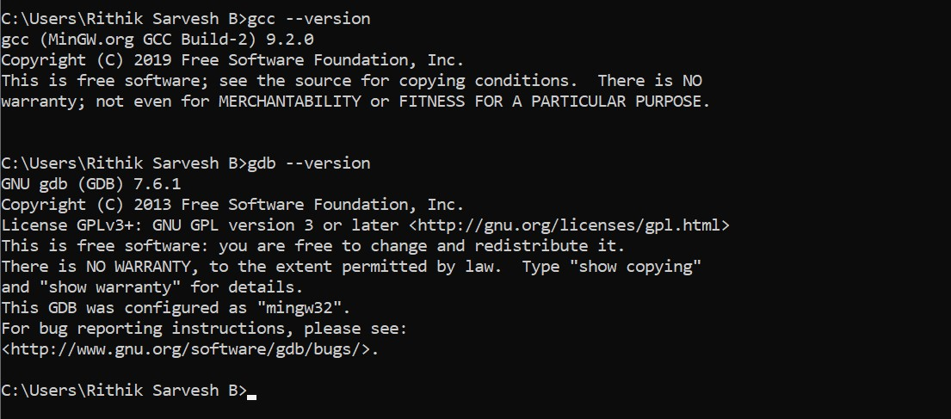

Windows:

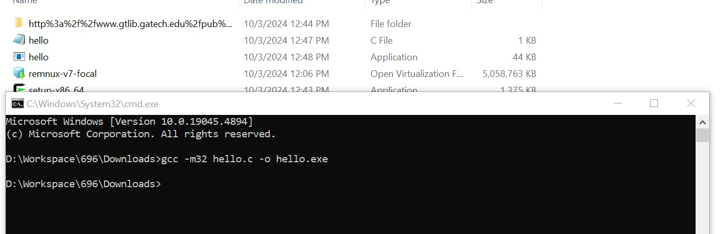

Remux:

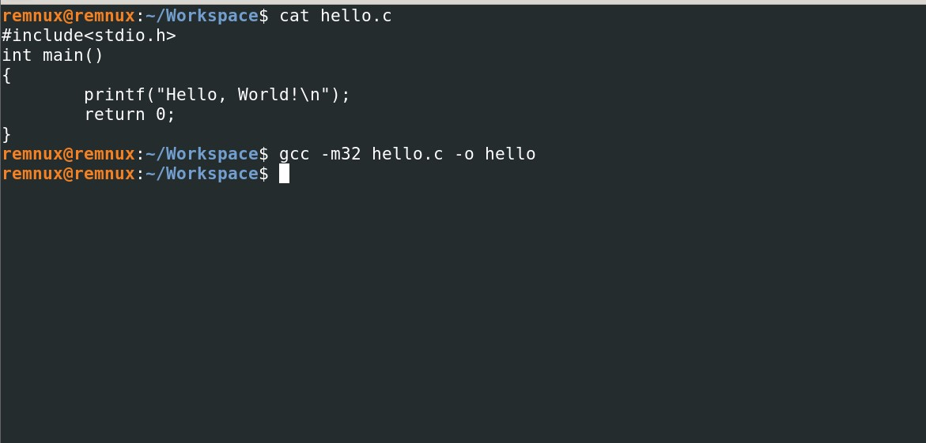

PE version:

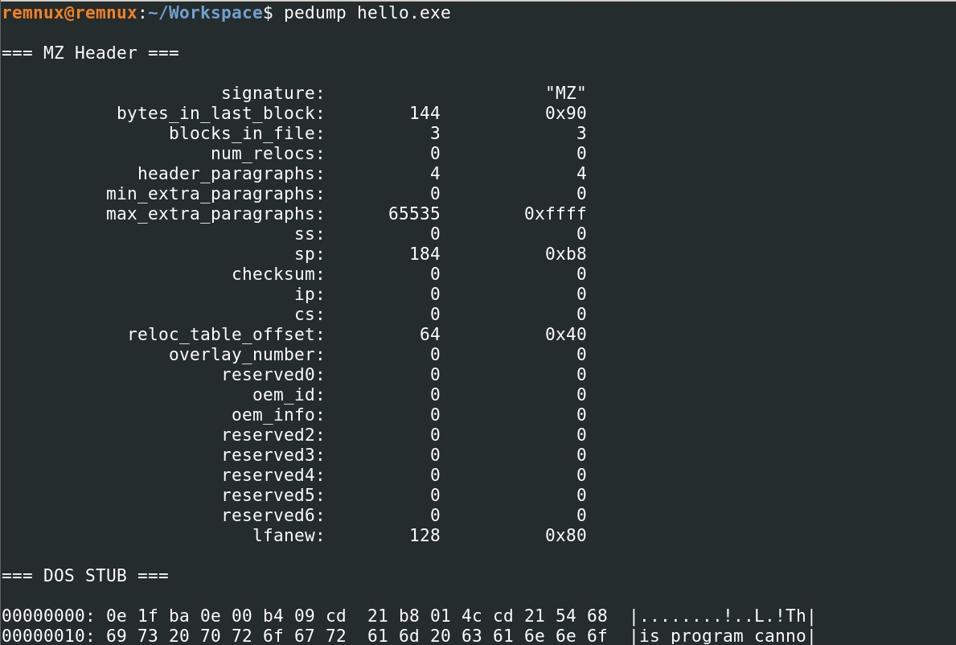

ELF version:

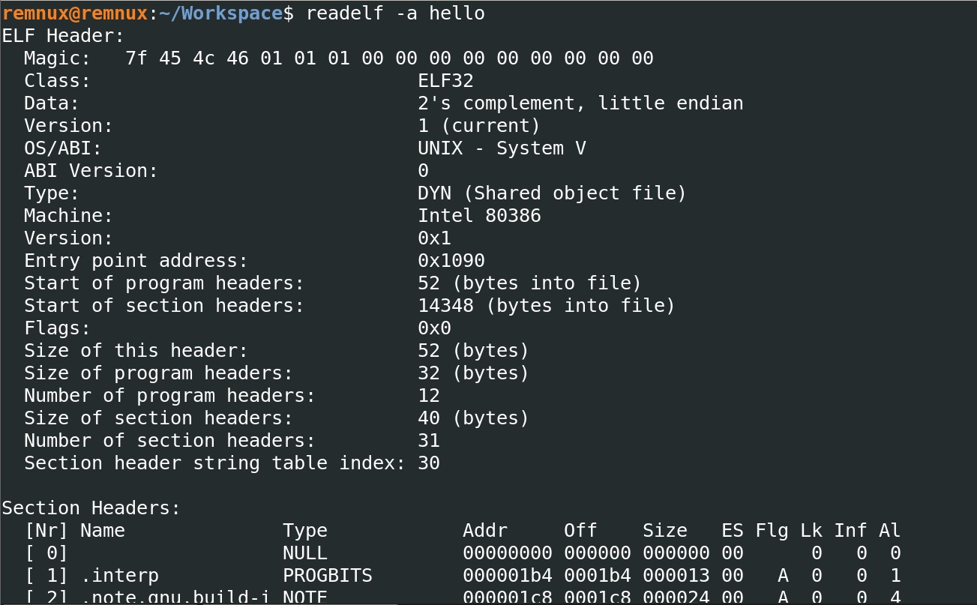

Comparison between PE file and the ELF file

PE file:

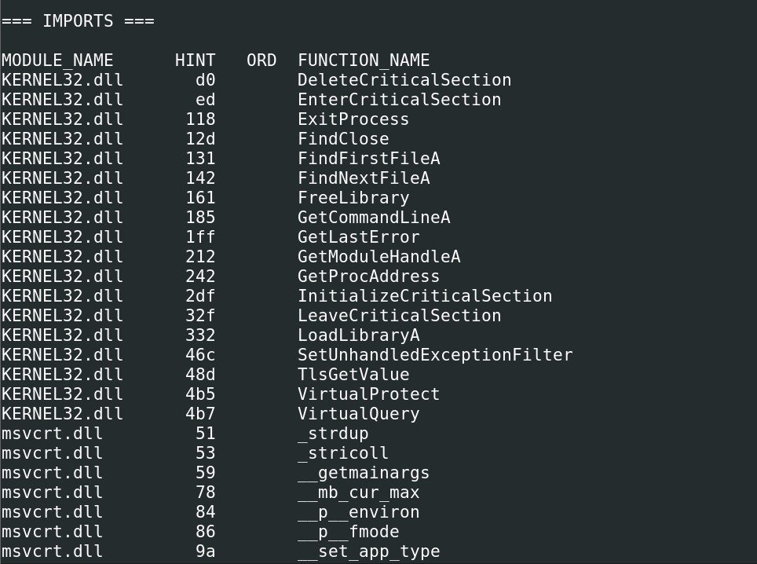

ELF file:

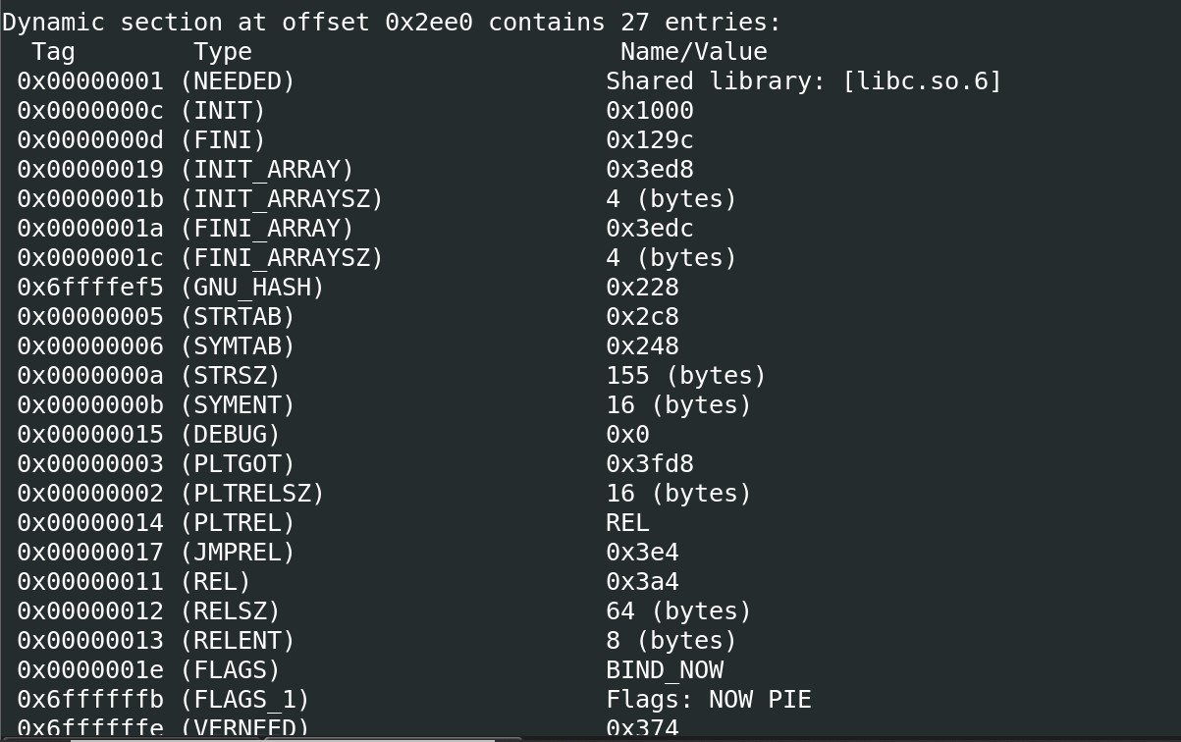

Conclusion:

In PE file, the import functions and the DLLs are specifically mentioned in the IMPORTS section whereas in ELF file, they are mentioned in offsets. (i.e.) libc.so.6 is the shared c library in linux.